**Internship report**

**Projects –**

* PM – Poshan Yojna
* Occupational Segregation, Job Discrimination and Wage Disparity against Women – A Study of Urban Labour Market in Uttar Pradesh.

**Name of the interns -**

1. Muskan Bhama
2. Akriti Agarwal
3. Rini Durgapal
4. Tushar Maurya
5. Deepak kumar
6. Aditya Agarwal



**Giri Institue Of Development Studies**

**Introduction**

We are a group of 6 interns from Lucknow University. We got the opportunity of working on two projects of great importance for the Social welfare at The Giri Institute of Development Studies –

‘‘PM Poshan Yojna’’ and “Occupational Segregation, Job Discrimination and Wage Disparity against women – A study of Urban Labour Market.”

Mid day meal is a scheme under which every school going child from class 1 to 8 is given one full meal daily during the school hours. PM Poshan Yojna is a revamped form of this Mid day Meal scheme launched for 5 years initially.

On 15th August 1995, a scheme named ‘National Programme of Nutritional Support to Primary

Education (NP-NSPE)’. In October 2007, NP-NSPE was renamed as ‘National Programme of Mid Day Meal in Schools,’ which is popularly known as Mid-Day Meal Scheme.

Through a study of the Urban Labour Market, the working condition of people at different positions and the condition of women in the Labour market can be understood, which is an important step towards betterment of the betterment of the working conditions for Women and the work force in general.

So this study has been done on the newly revamped version of MDM – ‘PM Poshan Yojna’ to understand how it is being implied and analyze it’s performance on ground.

**Data Feeding:**

* PM- Poshan Yojna

**Objective:**

**Major objectives of the Mid Day Meal Scheme are:**

* To make available nutritious food to children enrolled in Classes 1-8 in schools
* To develop the grasping power of children by improving their nutrition level.
* To enhance the enrolment of children in schools.
* To develop a tendency in the children to stay in school, especially during school-interval, and to reduce the dropout rate.
* To foster the feeling of brotherhood and to develop positive outlook through co-eating and combined food preparation for the children belonging to different religions and castes and socio-economic backgrounds.

**Social Audit of MDM Scheme:**

The followings are the major aspects which have been covered in social audit of MDM.

* + Regularity in MDM Supply
  + Use of MDM
  + Supply of food grains
  + Regular payment of food grain cost
  + Social equity in MDM
  + MDM supply as per menu
  + Satisfaction of students with quantity and quality of

MDM

* + Status on personal hygiene of cooks
  + MDM infrastructure
  + Safety and hygiene
  + Community participation
  + Inspection and supervision
  + Impact of MDM

**PROCEDURE**:

* Under this scheme We had 1200 schedules collected on various parameters of 10 districts on mdm yojana

Social audit on mdm scheme were conducted in following districts:

* Mau
* Deoria
* Kushinagar
* Ballia
* Basti
* Sant Kabir Nagar
* Maharaj Ganj
* Azamgarh
* Siddharth Nagar
* Gorakhpur
* 20 schools were covered in each of sample districts. Out of 20 schools, 10 have been selected from each of the two selected blocks per district.
* first, we fed the data from the schedules in the CS pro software
* according to the schedules we had the template on CS pro and we fed the data of respective schedules
* We had the categorical data on which we performed encoding
* We also performed encoding on reviews too.

# DATA COLLECTION

* We have collected data on the project named

“OCCUPATIONAL SEGREGATION, JOB

DISCRIMINATION AND WAGE DISPARITY AGAINST

WOMEN A STUDY OF URBAN LABOUR MARKET IN UTTAR PRADESH”

* This interview schedule is for employee
* This study of urban labour market is about is there still any discrimination against women in jobs or in society.
* It contains different set of questions to conquer our objective

**It contains**

o Profile of respondent

o Migration status

o Demographic structure

o Employment status

o Promotion and training

o Labour market and recruitment

o Awareness of labour law rules

o Women related questions and

* + Impact of covid 19

**EXPERIENCE**

* We went to different places like malls ,showrooms, offices, jangadna bhawan, amarujala, university etc. and collected data from different type of people and gain so much of experience in this field.
* There are some people who are not comfortable in sharing there personal information hence we faced some rejection too but most of the time after making them comfortable about the schedule they became willing to share their info
* We have come across people who gets emotional while sharing about their life situation ,we confronted them and make them realize that they are doing fine
* There are handsome amount of people who share their experience about how they have faced discrimination and harassment in their job , there is a lady whose colleagues use abusive language and misbehave around her ,there is a man whose juniors do not behave properly and obey him etc.
* We have also met people who inspired us by their work and how they manage their lifestyle and we got impressed by their hardwork.

**DATA ANALYSIS**

**We** have done analysis on the project PM POSHAN YOJNA

We have given data of 200 schools as there are 10 district per district have 2 blocks and every block have 10 schools

WE HAVE PROVIDED THE DATA OF SCHOOLS OF TEN DISTRICT EACH OF THEM HAVE 2 BLOCKS AND EVERY BLOCK HAVE 10 SCHOOLS.

## RANKING ACCORDING TO PRIORITIES:-

|  |  |  |
| --- | --- | --- |
| **PRIORITIES** | **WEIGTAGE** |  |
| DRINKING_WATER_AND_HANDWASH |  | .25 |
| CLEANLINESS |  | .15 |
| FOOD PROVIDED |  | .09 |
| THE QUALITY OF FOOD GRAIN |  | .089 |
| SEPARATE FUNCTIONAL TOILETS |  | .085 |
| PAINTING AND DECO |  | .07 |
| BOUNDARY WALL AND GATE POSITION |  | .06 |
| ENVIRONMENT |  | .057 |
| SECURITY |  | .055 |
| ARRANGEMENT FOR WATER DRAIN |  | .05 |
| WHETHER COOKED MID DAY MEAL |  | .044 |

## PROCEDURE

### For obtaining the rank table according to the priorities we first go to the table and selected priorities and by compute means we apply following formula DRINKING_WATER_AND_HANDWASH * .25 + C_CLEANLINESS * .15 + SFF * .09 + IS_THE_QUALITY_OF_FOOD_GRAI * .089+ SEPARATE_FUNCTIONAL_TOILETS * .085 + PAINTING_PAINTING_AND_DECO * .07 + BOUNDARY_WALL_AND_GATE_POSI * .06 + A_ENVIRONMENT * .057 + B_SECURITY * .055 + ARRANGEMENT_FOR_WATER_DRAIN * .05 + WHETHER_COOKED_MID_DAY_MEAL * .044 Then by compare mean tab we club all the district and find their mean and sum and by ranking menu we ranked them and got our following table

**RANK ACCORDING TO THE PRIORITIES GIVEN**

**DISTRICT MEAN SUM**

|  |  |  |
| --- | --- | --- |
| Kushinagar | 1.91 | 38.11 |
| Mau | 1.84 | 33.12 |
| Siddharth Nagar | 1.79 | 35.8 |
| Gorakhpur | 1.77 | 35.44 |
| Ballia | 1.68 | 33.55 |
| Deoria | 1.59 | 31.86 |
| Maharajganj | 1.55 | 30.91 |
| Basti | 1.53 | 30.62 |
| Azamgarh | 1.52 | 28.91 |
| Sant Kabir Nagar | 1.41 | 28.18 |

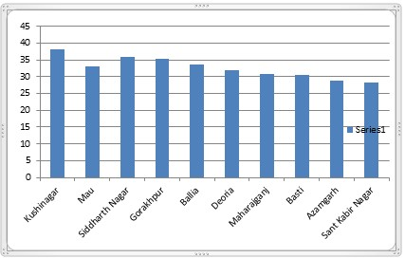

**RANK ACCORDING TO ENROLLMENT AND ACTUALLY PRESENT AT THE DAY OF AUDIT**

## PROCEDURE

### By compare mean tab we club the entire district and find difference and sum of enrolled students , who are present at that time of audit and by ranking menu we ranked them and got our following table

**TOTAL – PRESENT = DIFFRENCE**

**DISTRICT DIFFRENCE TOTAL PRESENT**

|  |  |  |  |
| --- | --- | --- | --- |
| Gorakhpur | 915 | 2174 | 1259 |
| Sant Kabir Nagar | 1034 | 2474 | 1440 |
| Azamgarh | 1194 | 2989 | 1795 |
| Basti | 1215 | 2758 | 1543 |
| Kushinagar | 1257 | 2576 | 1319 |
| Maharajganj | 1289 | 3577 | 2288 |
| Deoria | 1396 | 3401 | 2005 |
| Siddharth Nagar | 1397 | 2816 | 1419 |
| Ballia | 1569 | 3510 | 1941 |
| Mau | 1578 | 3448 | 1870 |

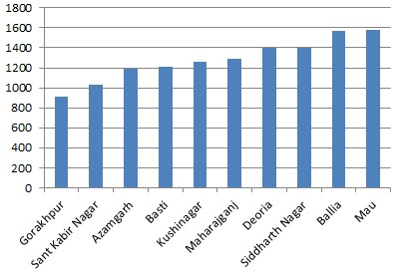

**RANK ACCORDING TO MEAL REGISTERED AND ACTUALLY NO. WHO HAD AT THE DAY OF AUDIT**

## PROCEDURE

By compare mean tab we club the entire district and find difference and sum of registered students and who are present at that time of audit and by ranking menu we ranked them and got our following table.

**Number of students taking food as per mid-day meal register - How many students actually had mid-day meal in the school on the day of social audit = diffrence of registered to have food to actually had meal**

32.6 How many students

diffrence of 32.5 Number of actually had

registered to students taking mid-day meal in have food to food as per the school on actually had mid-day meal the day of

1. Name of District meal register social audit?

|  |  |  |  |
| --- | --- | --- | --- |
| Maharajganj | 0 | 2288 | 2288 |
| Ballia | 0 | 1925 | 1925 |
| Basti | 0 | 1543 | 1543 |
| Deoria | 0 | 2005 | 2005 |
| Gorakhpur | 0 | 1259 | 1259 |
| Mau | 0 | 1825 | 1825 |
| Sant Kabir Nagar | 0 | 1439 | 1439 |
| Siddharth Nagar | 0 | 1400 | 1400 |
| Total | 3 | 16798 | 16767 |
| Azamgarh | 4 | 1795 | 1763 |
| Kushinagar | -1 | 1319 | 1320 |

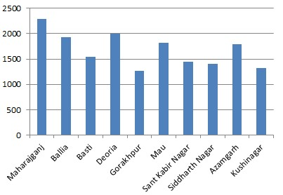

**RANK ACCORDING TO NO. OF TEACHERS ENROLLED AND ACTUALLY NO. WHO ARE PRESENT AT THE DAY OF AUDIT**

## PROCEDURE

By compare mean tab we club the entire district and find difference and sum of registered teachers and who are present at that time of audit and by ranking menu we ranked them and got our following table.

**difference of no. of teacher enrolled to no. of present at that day=. Total number of teachers working in the school- Number of teachers present on the day of audit**

difference of

no. of teacher

enrolled to no.

of present at

|  |  |  |  |
| --- | --- | --- | --- |
| Mau | 0 | 99 | 99 |
| Azamgarh | 2 | 95 | 93 |
| Kushinagar | 3 | 69 | 66 |
| Siddharth Nagar | 4 | 65 | 61 |
| Sant Kabir Nagar | 6 | 84 | 78 |
| Basti | 7 | 84 | 77 |

1. Name of District that day

8. Total

number of 9. Number of teachers teachers

working in the present on the school day of audit

|  |  |  |  |
| --- | --- | --- | --- |
| Deoria | 7 | 99 | 92 |
| Gorakhpur | 8 | 91 | 83 |
| Maharajganj | 9 | 92 | 83 |
| Ballia | 11 | 97 | 86 |

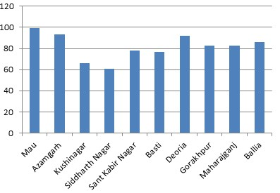

**AGGREGATE OF ALL RANKINGS**

## PROCEDURE

Afterall we obtain percentage of each table by dividing present to total amount and then we calculated aggregate score.

**DISTRICT** A B C D PERCENATGE **Mau** 33.12 100 54.23 100 71.84

**Maharajganj** 30.91 90.22 63.96 100 71.27

**Azamgarh** 28.91 97.89 60.05 98.22 71.27

|  |  |  |  |  |  |
| --- | --- | --- | --- | --- | --- |
| **Kushinagar** | 38.11 | 95.65 | 51.2 | 100.08 | 71.26 |
| **Gorakhpur** | 35.44 | 91.21 | 57.91 | 100 | 71.14 |
| **Deoria** | 31.86 | 92.93 | 58.95 | 100 | 70.94 |
| **Siddharth Nagar** | 35.8 | 93.85 | 50.39 | 100 | 70.01 |
| **Sant Kabir Nagar** | 28.18 | 92.86 | 58.21 | 100 | 69.81 |
| **Basti** | 30.62 | 91.67 | 55.95 | 100 | 69.56 |
| **Ballia** | 33.55 | 88.66 | 55.3 | 100 | 69.38 |

### WHERE A IS PERCENTAGE OF PRIORITIES B IS PERCENTAGE OF TEACHERS PRESENT C IS PERCENTAGE OF TOTAL ENROLLMENT D IS PERCENTAGE OF MEAL EATEN

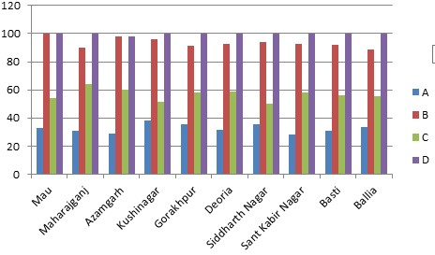

### **ABOVE GRAPH GIVES US THE CONCLUSION THAT MAU IS BEST PERFORMING AMONG ALL THE DISTRICT**